
2025-26 Team FAQ

KTP Racquet Club badminton teams are the next step for athletes that are looking to become competitive badminton players. Our Team programs are what helped build KTP Racquet Club up to what it is today and offers the most competitive badminton program north of Toronto. The purpose of our teams is to take athletes of all skill levels and train them to achieve their personal goals and reach the highest level of play that their potential has to offer. We have five different teams, offering something for all ages and skill levels.

Who can play on a KTP Racquet Club team?
One of the best parts about our teams is that there are no tryouts, and there is no cap to the number of participants! Each team has specific requirements to be eligible for that specific team based on prior training experience. Having a strong work ethic and focus are key assets that help with competitive badminton development.

Team Descriptions & Minimum Requirements
The Pre-Competition Team (ages 6-10) trains twice per week and is intended for athletes with prior badminton experience. This team focuses on developing a strong foundation while learning proper footwork, technique, and match play. Athletes looking to join this team must have participated in a prior KTP badminton program (group/private lessons or summer camps) and must have successfully learned and can perform the foundational skills (net shot, lift, drive, clear, drop, serve, front and back court footwork, and understanding of match play).
The Junior Development Team (ages 11-14) trains twice per week and focuses on developing techniques for beginner-intermediate badminton players. This team attends Northern Ontario Badminton Association tournaments and championships. More experienced athletes may consider competing at Badminton Ontario Jr C level tournaments. Consult with the coach to learn more about these provincial tournaments. Athletes looking to join this team must have participated in a prior KTP badminton program (group/private lessons or summer camps) and must have successfully learned and can perform the foundational skills (net shot, lift, drive, clear, drop, serve, front and back court footwork, and understanding of match play).
The Development Team (ages 14-18) trains twice per week and focuses on developing techniques for intermediate level athletes. Athletes on this team must have prior badminton experience. This team attends Northern Ontario Badminton Association tournaments and championships. More experienced athletes may consider competing at Badminton Ontario Jr C level tournaments. Consult with the coach to learn more about these provincial tournaments. Athletes looking to join this team must have participated in a prior KTP badminton program (group/private lessons or summer camps) and must have successfully learned and can perform the foundational skills (net shot, lift, drive, clear, drop, serve, front and back court footwork, and understanding of match play).
The Junior High-Performance Team (ages 11-15) trains twice per week (in addition to one fitness session) and is intended for intermediate-advanced athletes. This group focuses on solidifying base skills, and developing advanced movement, technique, and match play for the athlete. This team attends a combination of Badminton Ontario Jr B /C, Northern Ontario Badminton Association tournaments and championships. Athletes looking to join this team must have prior experience training on one of our teams. In addition, athletes must (1) be very consistent at the foundational skills, (2) understand and implement singles and doubles strategy and rotations, (3) have an appropriate training mindset and worth ethic, (4) have consistent and proper footwork to move around the full court and (5) understand and implement more advanced skills (slice, net spin, half smash, etc…).
The High-Performance Team (14-18) trains twice per week (in addition to one fitness session) and is for experienced, advanced athletes. This group focuses on maintaining and improving the skills and fitness levels required to be competitive on the provincial circuit and beyond. This team attends a combination of Badminton Ontario Jr A/B/C tournaments and championships. Athletes looking to join this team must have prior experience training on one of our teams. In addition, athletes must (1) be very consistent at the foundational skills, (2) understand and implement singles and doubles strategy and rotations, (3) have an appropriate training mindset and worth ethic, (4) have consistent and proper footwork to move around the full court and (5) understand and implement more advanced skills (slice, net spin, half smash, etc…).
Not sure where you or your athlete fits in? Contact us directly for a free assessment
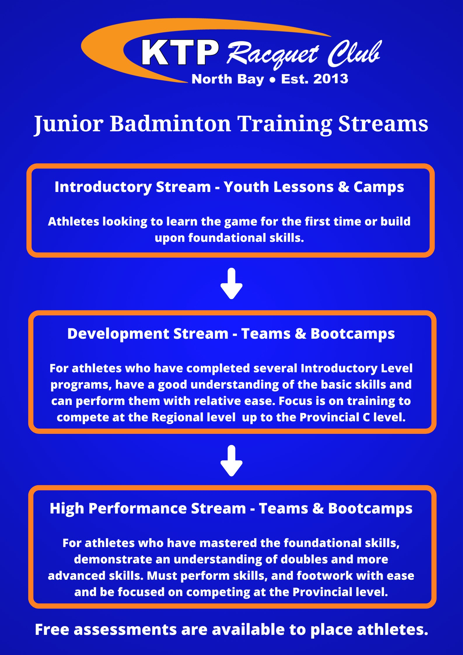

When does the team practice?
All practices begin the week of September 8th and run until the end of April. Additional training options are available throughout the season (in the form of bootcamps, training camps, and private lessons), as well as opportunities post-season, including group and private lessons, bootcamps, and summer camps.

Pre-Competition Team: Wednesdays from 6:00-7:30PM and Sundays from 9:00-11:00AM
Junior Development Team: Tuesdays from 5:00-7:00PM and Sundays from 9:00-11:00AM
Development Team: Thursdays from 7:00-9:00PM and Sundays from 3:00-5:00PM. Athletes are encouraged to stay from 9:00PM-10:00PM on Thursdays to play matches together on the designated courts, there is no additional charge for this.
Junior High-Performance Team: Thursdays from 5:00-7:00PM and Sundays from 1:00-3:00PM. There is also a mandatory team fitness session from 3:00-3:45PM on Sundays.
High-Performance Team: Tuesdays from 7:00-9:00PM and Sundays from 11:00AM-1:00PM. There is also a mandatory team fitness session from 1:00PM-1:45PM on Sundays. Athletes are encouraged to stay from 9:00PM-10:00PM on Tuesdays to play matches together on the designated courts, there is no additional charge for this.

Membership and Team Fees
All team members (except the Pre-Competition Team) are required to have a Club Membership. This membership not only earns you discounts on all club programs, but also affiliates you with Badminton Ontario, which provides sport-accident insurance among other perks. The annual membership is $60 (taxes included).

Team Fees
Pre-Competition Team: $750 (taxes included), membership not required
Junior Development Team: $825 (taxes included), plus club membership
Development Team*: $875 (taxes included), plus club membership
Junior High-Performance Team*: $925 (taxes included), plus club membership
High-Performance Team*: $975 (taxes included), plus club membership
*Athletes on any of these teams will also need to purchase a Badminton Ontario player card (if they plan to attend any Badminton Ontario tournaments), prior to their first Badminton Ontario tournament (these usually range from $60-80 depending on the membership level – A/B/C).
Team fees may be paid by cash, cheque or e-transfer.
In addition to the team fees there are tournament fees. Every tournament has a different entry fee (typically in the $45-80 range depending on the level of the event), as well as accommodations that must be covered by the athlete.

What is included in my team fee?
The team fee includes:
- Two training sessions per week
- 1-3 professionally trained coaches per training session
- Training shuttles
- Coaches at many of the tournaments from the tournament calendar
- Club team shirt

Who coaches these teams?
The Head Coach is Kurt Tempelmans Plat, a certified Provincial Competition-Development Level NCCP coach (formerly known as Level 3). He has 15+ years of coaching experience and has created and developed one of the most comprehensive badminton programs north of Toronto. Kurt was the badminton coach for Team Ontario at the 2017 Jeux de la francophonie Canadienne, where his team brought home four medals. He was also selected to coach again at Les Jeux, however the event was cancelled due to the pandemic. In 2022 and 2024, he was selected to coach Team Northern Ontario at the Ontario Winter Games. At the 2022 edition of the OWG his team earned the bronze medal, its first medal in 30 years. Over the years some of Kurt’s athletes have achieved some significant results including: 2019 U15 Boys Singles & 2023 U19 Boys Doubles Jr B Provincial Champion, dozens of medals at provincial Jr B tournaments, hundreds of regional and Northern Ontario Badminton Association medals, 50+ Northern Ontario Badminton Association junior champions, and dozens of athletes qualifying for OFSAA Badminton. Kurt has also been the NOBA President since 2016, as well as the Director of Coaching for Badminton Ontario from 2019-2022.
The club’s primary assistant coach is Daniel Kerr, a certified Regional Level NCCP Coach (formerly known as Level 1). Dan was a former KTP athlete who competed at OFSAA and was a provincial junior B medalist. He has been coaching at the club since 2022 and is a quality coach with a great understanding of both technical and tactical skills. Supporting KTP with many teams and camps, Dan also takes on individuals in private training as well. His outgoing personality and attitude cannot be missed around the club, making him the full coaching package.
The club’s other assistant coach is Olivia Popp, former KTP athlete turned coach. Olivia has plenty of playing experience, competing at the Ontario Winter Games, winning several NOBA titles, several Junior B provincial medals, and an OFSAA appearance to her name. Her years of training and tournament experience allow her to give clear vision and instruction while coaching the club’s youth. She is now in her second year on with the KTP coaching staff and is the main coach in charge of Junior Match Night.
Kurt will be assisted by other NCCP trained coaches throughout the season as needed. These may include, but are not limited to: Lilly Wolfe, and Zoéanne Dubien.

What equipment does the player need?
Athletes are expected to have their own racquet and a pair of court shoes or non-marking indoor running shoes. A pair of court shoes are recommended as they are made specifically for court surfaces and to support the movements used in badminton, such as lunging or jumping. Protective eyewear is mandatory for competitions. Our club has a fully stocked pro shop that can help you with any of your badminton needs.

What is the expectation of athletes on the team?
Athletes are expected to be committed and motivated throughout their experience. This team is Northern Ontario’s top badminton training program; it is for those that want to be at the top of their game, are motivated to learn, and are committed to practices and tournaments. Respect is the most important and fundamental value of KTP Racquet Club. We expect that all athletes respect the coaches, teammates, opponents, the equipment, the venue, and themselves. We have zero tolerance for lack of respect towards any of the latter.
This team is just that, a team; although badminton is an individual sport, we expect that all players work and socialize with one another and are there to support one another on and off court, at practice and at tournaments. We have built a defining team culture at KTP that resonates with the team members and is often regarded by parents and others as a unique and wonderful experience.

Junior Match Night
Junior Match Night is different from a normal drop-in night as there will be at least one coach there for the entire session. Throughout the 2-hour session athletes will be organized into singles and doubles matches and will receive active coaching by the coach(es) working that evening. Our professional, certified coaches will provide a variety of advice from technical changes to strategic improvements throughout the session. This is a great way to implement what you learn in training in a match scenario before competing at tournaments. This session is also open to non-team members; anyone can come for Junior Match Night! The age limit for the junior match night is 9-16. The session runs every Friday from 5:00PM-7:00PM. All shuttles are supplied by the club for the junior match night session.
The fee per session is $16 (taxes included) for members and $18 for non-members. We also have 10-pass cards valued at $145 for members that can be purchased.
Junior Match Night is every Friday of the year! Come on out any time!

Is there any team clothing available?
Players may purchase the following items:
Additional Jerseys (includes name and logo on the back) - $40 taxes included
Hoodie (without last name on the back) - $60 taxes included
Hoodie (with last name on the back) - $65 taxes included
Long Sleeve (dry fit with We the North logo and last name on the back) - $45 taxes included

How do tournaments work?
Pre-Competition Team: These athletes typically will not travel to out-of-town tournaments as there are little-to-none for this age group. We focus primarily on skill development and preparation for competition with this group. That said, our club does host a few in-house tournaments to help these athletes learn and compete at their leisure.
Junior Development and Development Team: Athletes are not required to attend every tournament; however, it is encouraged to attend as many as possible. There are usually three Northern Ontario Badminton Association (NOBA) tournaments in North Bay (two), and Sudbury, as well as a season-end championship held in a different northern city each year. Badminton Ontario also hosts a Jr C circuit that athletes with enough experience could consider competing in.
All tournaments are different, some begin on Friday and end on Saturday, while others begin on Saturday and end on Sunday. Once we have confirmed tournament dates, we will keep everyone up to date. Usually, we have most of the tournament dates by mid-September.
Junior High-Performance and High-Performance Team: These athletes are expected to attend a variety of Badminton Ontario tournaments (Jr A/B/C). They are not expected to attend any regional tournaments (except for the NOBA championships). Typically, the head coach will select several Jr A, Jr B, and Jr C tournaments to attend as a team. This makes it easier to travel as a club but also makes it easier for the head coach to attend a specific number of events. Athletes are encouraged to attend tournaments outside of the ones suggested by the head coach if they are looking for additional experience. Athletes interested in attending national circuit tournaments are encouraged to communicate directly with the head coach.

What events do the players participate in?
Every tournament includes entry to either U14/U16/U19 draws (NOBA), or U11/U13/U15/U17/U19 (Badminton Ontario) in the following events: singles, doubles and mixed doubles for every team member.
Your tournament age group is dictated by your birthyear for the season NOT your current age. For the 2025-26 Season the age groups are as follows:
- U11 = 2016 or younger
- U13 = 2014 or younger
- U15 = 2012 or younger
- U17 = 2010 or younger
- U19 = 2008 or younger (NOBA events allow 2007 and younger)

How do players get to tournaments?
Parents are more than welcome to attend and transport their athlete. We have relied on coaches and parents in the past to help in bringing athletes, and we hope to continue in this manner this season!

Financial Assistance is available to help cover team fees!
There are two organizations that support families put their kids into sport:
KidSport will provide up to $300 to families that qualify (residing in North Bay only), to cover help team fees for the badminton season! For more information, please send us an email or reach out to the North Bay chapter of KidSport by dropping into the 2nd floor of City Hall or giving them a call at 705-474-0400 X2328.
If you live outside of North Bay, or did not meet the KidSport requirements, please visit http://jumpstart.canadiantire.ca. This is another great alternative to help reduce costs for families.
Take advantage of this exciting opportunity to help grow the sport and allow anyone to play badminton regardless of any barriers!

