Team FAQ

KTP Racquet Club badminton teams are the next step for athletes that are looking to become competitive badminton players. Our team programs are what helped build KTP Racquet Club up to what it is today and offers the most competitive badminton program north of Toronto. The purpose of our teams is to take athletes of all skill levels and train them to achieve their personal goals and reach the highest level of play that their potential has to offer. We have five different teams, offering something for all ages and skill levels.

Who can play on a KTP Racquet Club team?
One of the best parts about our teams is that there are no tryouts. Anyone is welcome to join one of our teams, you do not need to be a club member. With that said, each team has specific requirements to be eligible for that specific team. Having a strong work ethic and focus are key assets that help with competitive badminton development.

Team Descriptions & Minimum Requirements
The Pre-Competition Team (ages 7-10) trains twice per week and is intended for athletes with a little badminton experience. This team focuses on developing a strong foundation while learning proper footwork, technique, and match play. Participation in a prior KTP badminton program is an asset but not required.
The Junior Development Team (ages 11-14) trains twice per week and focuses on developing techniques for beginner-intermediate badminton players. This team attends Northern Ontario Badminton Association tournaments and championships. Athletes looking to join this team must have participated in a prior KTP badminton program (group/private lessons or summer camps) to be eligible to register for this team.
The Development Team (ages 14-18) trains twice per week and focuses on developing techniques for intermediate level athletes. Athletes on this team must have prior badminton experience. This team attends Badminton Ontario Jr C, and Northern Ontario Badminton Association tournaments and championships. Athletes looking to join this team must have participated in a prior KTP badminton program (group/private lessons, team, or summer camp) to be eligible for this team.
The Junior High-Performance Team (ages 11-14) trains twice per week (in addition to one fitness session) and is intended for intermediate-advanced athletes. This group focuses on solidifying base skills, and developing advanced movement, technique, and match play for the athlete. This team attends a combination of Badminton Ontario Jr B /C, Northern Ontario Badminton Association tournaments and championships. Athletes looking to join this team must have prior experience training on one of our teams, and/or participated in a high-performance camp. In addition, athletes must meet a certain standard/quality of play, have a strong understanding of all foundational badminton skills, and have an appropriate training mindset and work ethic to be eligible to join this team.
The High-Performance Team (14-18) trains twice per week (in addition to one fitness session) and is for experienced, advanced athletes. This group focuses on maintaining and improving the skills and fitness levels required to be competitive on the provincial circuit and beyond. This team attends a combination of Badminton Ontario Jr A/B/C tournaments and championships. Athletes looking to join this team must have prior experience training on one of our teams, and/or participated in a high-performance camp. In addition, athletes must meet a certain standard/quality of play, have a strong understanding of all foundational badminton skills, and have an appropriate training mindset and work ethic to be eligible to join this team.

Not sure where you or your athlete fits in?
Contact us directly and we can help sort you on to the right team for you.

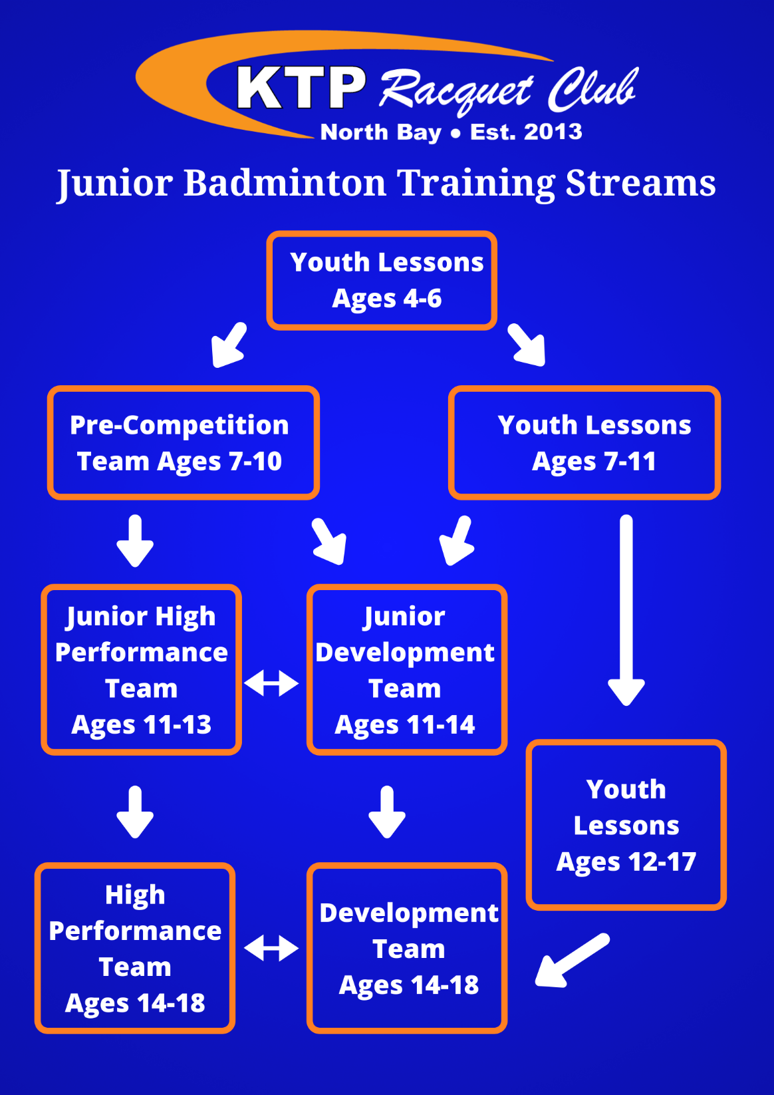

Who coaches these teams?
The Head Coach is Kurt Tempelmans Plat, a trained Provincial Competition-Development Level NCCP coach (formerly known as Level 3). He has 15+ years of coaching experience and has created and developed one of the most comprehensive badminton programs north of Toronto. Kurt was the badminton coach for Team Ontario at the 2017 Jeux de la francophonie Canadienne, where his team brought home four medals. He was also selected to coach again at Les Jeux, however the event was cancelled due to the pandemic. Over the years some of Kurt’s athletes have achieved some significant results including: 2019 U15 Boys Singles Jr B Provincial Champion, dozens of medals at provincial Jr B tournaments, hundreds of regional and Northern Ontario Badminton Association medals, 40+ Northern Ontario Badminton Association junior champions, and dozens of athletes qualifying for OFSAA Badminton. Kurt has also been the NOBA President since 2016, as well as the Director of Coaching for Badminton Ontario from 2019-2022.
Kurt will be assisted by NCCP certified coaches throughout the season as needed. These may include, but are not limited to: Nicholas Babich, David Rojas Reid, Daniel Kerr, and Pierre Legrand.

What equipment does the player need?
Athletes are expected to have their own racquet and a pair of court shoes or clean, indoor running shoes. A pair of court shoes are recommended as they are made specifically for court surfaces and to support the movements used in badminton, such as lunging or jumping. Protective eyewear is mandatory for competitions. Our club has a fully stocked pro shop that can help you with any of your badminton needs.

What is the expectation of athletes on the team?
Athletes are expected to be committed and motivated throughout their experience. This team is North Bay and area’s top badminton training program; it is for those that want to be at the top of their game, are motivated to learn, and are committed to practices and tournaments. Respect is the most important and fundamental value of KTP Racquet Club. We expect that all athletes respect the coaches, other players, opponents, the equipment, the venue, and themselves. We have zero tolerance for lack of respect towards any of the latter.
This team is just that, a team; although badminton is an individual sport, we expect that all players work and socialize with one another and are there to support one another on and off court, at practice and at tournaments. Players are expected to respect one another, and any lack of respect will not be tolerated at any time.

When does the team practice?
All practices begin the week of September 12 and run until the end of April. Additional training options are available throughout the season (in the form of group and private lessons), as well as opportunities post-season, including group and private lessons and summer camps.

Pre-Competition Team: Tuesdays from 5:00-6:30PM and Sundays from 9:00-10:30AM
Junior Development Team: Wednesdays from 6:00-7:30PM and Sundays from 9:00-10:30AM
Development Team: Thursdays from 7:00-9:00PM and Sundays from 2:30-4:30PM
Junior High-Performance Team: Thursdays from 5:00-7:00PM and Sundays from 12:30-2:30PM. There is also a team fitness session from 3:00-3:45PM on Sundays.
High-Performance Team: Tuesdays from 6:30-8:30PM and Sundays from 10:30AM-12:30PM. There is also a team fitness session from 1:00-1:45PM on Sundays.

Membership and Team Fees
NEW THIS SEASON – Memberships are NOT required to join a team. That said, we highly encourage all team players to join a team, especially those on the Junior High-Performance Team and the High-Performance Team. A half year junior membership is valued at $243.36+tax, and a full-year junior membership is $442.48+tax. As a special offer to our team members this season – we will give you 2 months free, on any 6-month junior or 12-month junior membership that you purchase. (If you purchased a 6-month or 12-month membership prior to the season, we will extend it by 2 months if you join a team). In addition, any team member purchasing at least a 6-month membership this season will receive 1 free private lesson (valued at $45).
Memberships grant access to all drop-ins, leagues, and court rentals at no extra cost, in addition to exclusive in-house events and deals. Members can also take advantage of exclusive access to our workout area, locker rentals, and shower rooms at no additional cost.

Team Fees
Pre-Competition Team: $530.97+tax (members and non-members)
Junior Development Team: $619.47+tax (members), $646.02+tax (non-members)
Development Team*: $716.81+tax (members), $752.21+tax (non-members)
Junior High-Performance Team*: $730.09+tax (members), $774.34+tax (non-members)
High-Performance Team*: $796.46+tax (members), $840.71+tax (non-members)
*Athletes on any of these teams will also need to purchase a Badminton Ontario player card (if they plan to attend any Badminton Ontario tournaments), prior to their first Badminton Ontario tournaments (these usually range from $60-100 depending on the membership level – A/B/C).
**Please note, team fees have been increased since the 2021-22 season. This is to reflect the fact that we will be hiring assistant coaches for larger programs (which was done by volunteers in the past). In addition, a club membership is no longer a requirement to join a team, which results in a lower overall cost to join the team. We appreciate your understanding with these changes. Our goal is to provide the highest quality experience possible with low coach to athlete ratios and professionally trained and experienced coaches.
Team fees may be paid by cash, cheque or e-transfer.
In addition to the team fees there are tournament fees. Every tournament has a different entry fee (typically in the $30-75 range depending on the level of the event), as well as accommodations that must be covered by the athlete.

What is included in my team fee?
The team fee includes:
- Two training sessions per week
- 1-2 professionally trained coaches per training session
- Training shuttles
- Coaches at many of the tournaments from the tournament calendar
- Club team shirt

How do I register for a KTP Racquet Club team?
Please visit www.ktpracquetclub.com, find the Teams page to register for one of our teams. Please do not hesitate to contact us directly if you have any questions. We do accept late registrations, so do not hesitate to register once the season has stated.

*New this season* Parent Gym Membership
Any parent that is has a child registered on one of our Teams is welcome to purchase a Parent Gym Membership. With this, you have full access to our workout area during your child’s practices. The Parent Gym Membership begins in September and lasts until the end of April, just as the teams do. The fee for this membership is $48.67+tax for the 8-months (per parent). This comes to an average of about $6/month. If you are already a club member, you do not need this membership as your club membership give you full access to the workout area already. To register, please notify us when registering your child.

*New this season* Junior Match Night
Starting in September of 2022 we are adding a new Junior Match Night. This is different than a normal drop-in night as there will be at least one coach there for the entire session. Throughout the 2-hour session athletes will be organized into singles and doubles matches and will receive active coaching by the coach(es) working that evening. Our professional, certified coaches will provide a variety of advice from technical changes to strategic improvements throughout the session. This is a great way to implement what you learn in training in a match scenario before competing at tournaments. This session is also open to non-team members; anyone can come for Junior Match Night! The session runs from 5:00PM-7:00PM and participants can come from 4:00PM-5:00PM to have some free time and warm-up beforehand (this is optional and is at no extra cost to the match night fee. This session will run every Friday evening unless there is a cancellation due to an upcoming event. All shuttles are supplied by the club for the match night session (5:00PM-7:00PM), anyone coming early to play or warm-up must supply their own shuttles.
The fee per session is $12.39+tax for members and $17.70+tax for non-members. We also have 10-pass cards valued at $106.19+tax for members and $159.29 for non-members that can be purchased.
The first Junior Match Night will be on Friday, September 23rd.

Is there any team clothing available?
Players may purchase the following items (all include the last name on the back):
Additional Jerseys - $35.40+tax
Hoodie (without last name on the back) - $53.10+tax
Hoodie - $57.52+tax
“We The North” Long Sleeve - $39.82+tax
Samples will be available in our store.

How do tournaments work?
Pre-Competition Team: These athletes typically will not attend tournaments as there are little-to-none for this age group. We focus primarily on skill development and preparation for competition with this group. That said, our club does host a few in-house tournaments to help these athletes learn and compete at their leisure.
Junior Development and Development Team: Athletes are not required to attend every tournament; however, it is encouraged to attend as many as possible. There are usually three Northern Ontario Badminton Association (NOBA) tournaments in North Bay, Sudbury and Timmins, as well as a season-end championship held in a different northern city each year. Badminton Ontario also hosts a Jr C circuit that we intend to bring our athletes to (there will likely be 2-3 of these including a championships).
All tournaments are different, some begin on Friday and end on Saturday, while others begin on Saturday and end on Sunday. Once we have confirmed tournament dates, we will keep everyone up to date. (Usually we have the majority of the tournament dates by this time in a typical year).
Junior High-Performance and High-Performance Team: These athletes are expected to attend a variety of Badminton Ontario tournaments (Jr A/B/C). They are not expected to attend any regional tournaments (except for the NOBA championships). Athletes interested in attending national circuit tournaments are encouraged to communicate directly with the head coach. Typically, the head coach will select several Jr A and Jr B tournaments to attend as a team. This makes it easier to travel/act as a club, but also makes it easier for the head coach to attend a specific number of events. Athletes may still attend tournaments outside of the ones suggested by the head coach.

What events do the players participate in?
Every tournament includes entry to either U14/U16/U19 draws (NOBA), or U11/U13/U15/U17/U19 (Badminton Ontario) in the following events: singles, doubles and mixed doubles for every team member.

How do players get to tournaments?
Parents are more than welcome to attend and transport their athlete. We have relied on coaches and parents in the past to help in bringing athletes, and we hope to continue in this manner this season!

What is the 2022-23 tournament schedule?
Typically the provincial schedule is released at the end of August, and the Northern Ontario schedule is released in September. As we receive these schedules, we will update you.

Financial Assistance is available to help cover team fees!
There are two organizations that support families put their kids into sport:
KidSport will provide up to $300 to families that qualify (residing in North Bay only), to cover help team fees for the badminton season! For more information, please send us an email or reach out to the North Bay chapter of KidSport by dropping into the 2nd floor of City Hall or giving them a call at 705-474-0400 X2328.
If you live outside of North Bay, or did not meet the KidSport requirements, please visit http://jumpstart.canadiantire.ca. This is another great alternative to help reduce costs for families.
Take advantage of this exciting opportunity to help grow the sport and allow anyone to play badminton regardless of any barriers!

